**Context**

* The World Happiness Report is a landmark survey of the state of global happiness . The report continues to gain global recognition as governments, organizations and civil society increasingly use happiness indicators to inform their policy-making decisions.
* Leading experts across fields – economics, psychology, survey analysis, national statistics, health, public policy and more – describe how measurements of well-being can be used effectively to assess the progress of nations.
* The reports review the state of happiness in the world today and show how the new science of happiness explains personal and national variations in happiness.

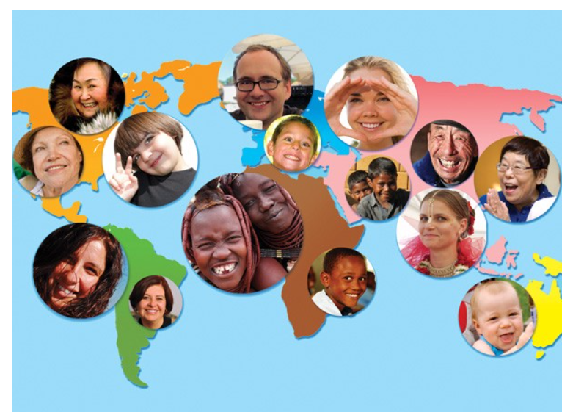

**What is Dystopia?**

* Dystopia is an imaginary country that has the world’s least-happy people. The purpose in establishing Dystopia is to have a benchmark against which all countries can be favourably compared (no country performs more poorly than Dystopia) in terms of each of the six key variables, thus allowing each sub-bar to be of positive width.
* The lowest scores observed for the six key variables, therefore, characterize Dystopia. Since life would be very unpleasant in a country with the world’s lowest incomes, lowest life expectancy, lowest generosity, most corruption, least freedom and least social support, it is referred to as “Dystopia,” in contrast to Utopia.

**Dataset Link**

[**https://www.kaggle.com/datasets/ajaypalsinghlo/world-happiness-report-2021**](https://www.kaggle.com/datasets/ajaypalsinghlo/world-happiness-report-2021)

**Please take a note there are two datasets which are associated**

**With above link and you need to consider both in order to solve the below tasks.**

# **Task of case study**

* To analyse World happiness data and to find the reason behind happiness of any country.
* how different factors  effect on **happiness score**.
* some visualizations related to **happiness score and other factors**.
* Top ten and bottom ten countries analysis on basis happiness score
* Happiest and Unhappiest Countries in 2021,2022,2023
* Relationship Between Happiness and Income
* Relationship Between Happiness and Freedom
* Relationship Between Happiness and Corruption
* Ladder Score Distribution by Regional Indicator
* Ladder Score Distribution by Countries in Map View
* Most Generous and Most Ungenerous Countries in 2021
* Relationship Between Features
* Conclusion